Question 1 of 1 You and your classmates are reading each other's shared digital documents. The document you are reading is well written, but you notice a factual error.You need to respectfully indicate the error to the author in a document comment.Which two actions should you take? (Choose 2)
A. Provide the correct information in your comment if you have it.
B. Point out the error without explanation.
C. Write the correction in capital letters to ensure that the author will see it.
D. Keep the tone of your correction positive.
Question 2 of 2 You find a social media post that shares inaccurate and misleading medical information. You decide to respond to the post. For each response, select Yes if it adheres to appropriate digital etiquette or No if it does not.
Statement | Yes | No
"WRONG! Did you do ANY RESEARCH before posting this?" |  | ◉
"Many doctors, including Jane Smith of Harvard Medical School, disagree." | ◉
"It can be difficult to research everything, but there are many different sources to look at concerning this issue." | ◉
"This is just wrong and makes you look foolish! Obviously you didn't look at the research from Harvard Medical School!" |  | ◉
Question 3 of 3 Match each description from the list on the left to the corresponding Boolean search string on the right.
Description | Correct Match
Returns results for either word | lions OR tigers
Returns results excluding one word | buffalo NOT bison
Returns results for either word if another word is included | (fish OR turtles) AND pacific ocean

Question 4 of 4 Select the option that allows you to secure Windows files or folders from unauthorized access.
- Encrypt contents to secure data
- Compress contents to save disk space
- File is ready for archiving
- Allow this file to have contents indexed

Question 5 of 5 When responding to an email, what is the best practice?
A. BCC your friend on important emails.
B. Use reply all to make responses faster.
C. Reply immediately if you are busy.
D. Take your time to provide a thoughtful response.
Question 6 of 6 You need to create a calendar event for a regular lunch meeting that will happen every Wednesday. Which option should you choose?
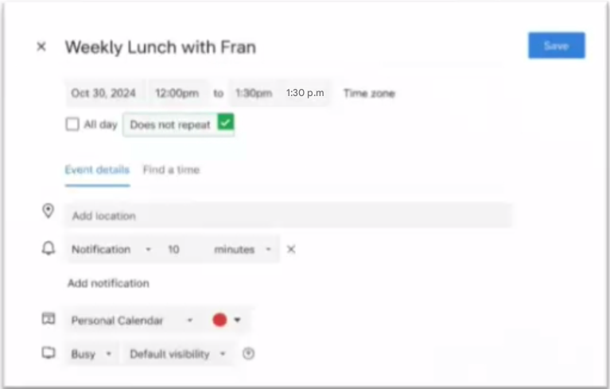

Question 7 of 7 Match each file extension to its corresponding file format description.
File Extension | Correct Description
.wav | A digital audio container for storing noncompressed or uncompressed audio data, often used for CD audio
.mp4 | A compressed video file that is optimal for devices with limited storage space
.mp3 | A compressed audio file that is optimal for devices such as tablets and smartphones
Question 8 of 8 Move each presentation term from the list on the left to its definition on the right.
Term (Tavsif) | Correct Definition (Atama)
A file that contains ready-made styles | Template
A special effect used to introduce slides | Transition
A slide that controls the design of the associated slide layouts | Master
A visual effect that moves placeholders, text, and images on and off slides | Animation

Question 9 of 9 For each statement about webcam security, select True or False.
Statement | True | False
It is recommended that everyone cover their webcam when not in use. | ☑ | ☐
All webcameras include a recording light that cannot be disabled through software. | ☐ | ☑
Disabling a webcam in your computer settings protects against any unauthorized access. | ☐ | ☑

Question 10 of 10 What is the primary purpose of using heading styles in a document?
A. To highlight important keywords throughout the document
B. To add color for emphasis in the text
C. To change the font size for visual differentiation
D. To create structure and enable a table of contents

Question 11 of 11 You are working on a collaborative team with three other people, and your team is discussing a task over email.
Your team disagrees about the task, and you feel strongly that your opinion is correct. Which two steps could you take to deal with this disagreement in a way that follows the standards of digital etiquette? (Choose 2)
A. Compose an email using strong language that shows how you feel about the task, and send it to everyone in your organization.
B. Pause the conversation to research the issue further, then compose a clear email describing your opinion.
C. Post about your team's disagreement publicly on social media and ask for the opinions of your friends and followers.
D. Schedule an in-person or virtual meeting with the whole team to discuss the task together face-to-face.
Question 12 of 12 For each physical symptom, select Yes if it is a sign of repetitive strain injury (RSI) or No if it is not.
Symptom | Yes | No
Pain | ☑ | ☐
Itching | ☐ | ☑
Tingling | ☑ | ☐
Weakness | ☑ | ☐

Question 13 of 13 Which two statements about document file permissions are true? (Choose 2)
A. Setting a document to Read-Only prevents others from making a new copy of the document.
B. The default setting for any new word processing document is Read-Only.
C. Setting a document to Read-Write allows others to change the document content and add comments to the document.
D. A Read-Only document can be viewed but not modified.
Question 14 of 14 Move each digital collaboration tool from the list on the left to its description on the right.
Collaboration Tool (Tavsif) | Correct Description (Vositasi)
Collaborators can edit files at the same time and automatically save their changes | Cloud file sharing
Collaborators can simultaneously brainstorm, review, and edit visual information by writing, drawing, and inserting images | Online whiteboard
Collaborators participate in learning activities and immediately share reactions, interpretations, and ideas for application of the ideas presented | Webinar

Question 15 of 15 You need to research whether a snake is a good pet to have... Which search result presents a different perspective from the other three?
A. Do Snakes Make Good Pets?
www.snakerights.org
Snakes are wild animals and should never be kept as pets. Even if they are not poisonous, they are dangerous and cannot be tamed.
B. How to Choose the Best Pet Snake For You
www.vetmed.famu.edu
Before choosing a pet snake, consider how much space you have to keep your snake. You will need a tank large enough for your snake to grow.

C. Snakes as Pets
www.petshop.com
Ball pythons and corn snakes make great pets that are easy to care for, but larger species like boas should be kept only by experienced professionals.

D. 11 Best Pet Snakes for Beginners
www.petchronicles.com
One of the best pet snakes for young pet owners is the corn snake. Corn snakes are small, calm, and have a beautiful color pattern.

Question 16 of 16 You are applying for a job in your chosen career field. Potential employers will access your professional online profile. What should you do to support your professional online profile?
A. Update the profile regularly to showcase your skills.
B. Restrict access to the profile to maintain privacy.
C. Include information about personal activities to demonstrate balance.
D. Include your salary history and expectations.

Question 17 of 17 A school principal is composing an email message to parents...
What should the principal do?
A. Send one message to a contact group that includes only the students' email addresses.
B. Send one message to all parents using the Cc field.
C. Send a message to the parent of each student who has been tardy.
D. Send one message to all parents using the Bcc field.

Question 18 of 18 What are two universal design principles for computing hardware?
(Choose 2)
A. Easy to keep clean
B. Size and space for approach and use
C. Equitable use
D. Internet of Things connected

Question 19 of 19 You are preparing to write a research paper. You find a scientific study that relates to your topic. You need to determine whether the study is credible. For each statement, select Yes if you should consider it when determining the credibility of the study or No if you should not. Note: You will receive partial credit for each correct answer.
Statement | Yes | No
The popularity of the study | ☐ | ☑
The organization that funded the study | ☑ | ☐
The entity that published the study results | ☑ | ☐

Question 20 of 20 You are creating a project proposal document with a partner... In what sequence should the actions be performed?
Chap ustun (Amallar) | O'ng ustun (To'g'ri tartib)
Add comments and track changes in the document | 1. Create a new document and upload it to cloud storage
Share a link to the document | 2. Share a link to the document
Create a new document and upload it to cloud storage | 3. Add comments and track changes in the document
Review and accept or reject comments and changes | 4. Review and accept or reject comments and changes

Question 21 of 21 Your company wants to improve the design of an electric ride-on vehicle it manufactures. You need to survey retail customers who purchased the vehicle and provide usable feedback to help achieve the goal
Question | Yes | No
Do you like the vehicle? | ☐ | ☑
What would make the vehicle better? | ☑ | ☐
What are the most important features of the vehicle? | ☑ | ☐
Would you recommend this ride-on vehicle to a friend? | ☑ | ☐

Question 22 of 22 For each statement about the difference between CPUs and GPUs, select True or False.
Statement | True | False
You typically upgrade a laptop GPU by replacing the display | ☐ | ☑
Some CPUs have a built-in GPU and don't rely on a graphics card | ☑ | ☐
Many modern computers and game systems have only a GPU and not a CPU | ☐ | ☑
Modern GPUs run increasingly complex workloads, including deep learning and artificial intelligence | ☑ | ☐

Question 23 of 23 You are in a loud room... What should you do to hear audio through the headphones instead of the speakers?
A. Manage output devices
B. Mute your computer speakers
C. Manage input devices
D. Configure Ease of Access audio settings
Question 24 of 24 Move the Artificial Intelligence ethical challenge on the left to its description on the right.
Ethical Challenge (Etik muammo) | Correct Description (Tavsifi)
AI's limited comprehension of social norms and cultural aspects can result in inappropriate or false content | Lack of contextual understanding
AI-generated content may perpetuate stereotypes or discriminatory views, influencing public opinion negatively | Promotion of harmful biased views
AI may exhibit limited openness, potentially misleading the audience regarding the origin and intent of the content | Deception and lack of transparency
AI can create manipulated media that may deceive individuals, spread misinformation, and undermine trust in visual evidence | Deepfake development

Question 25 of 25 You need to change the speed of the mouse cursor as it moves across your computer screen. Which option should you choose?
Tracking speed
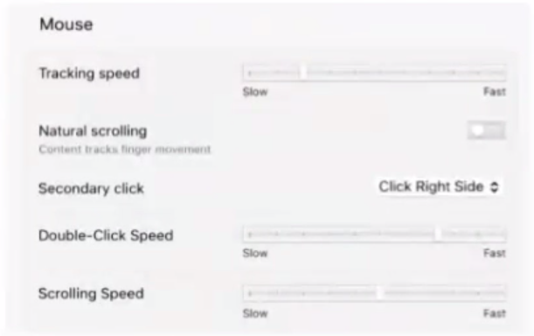
Question 26 of 26 You are working on your laptop computer in a sunny outside area. You need to minimize eyestrain. Which monitor setting should you adjust?
A. Contrast
B. Sharpness
C. Scale
D. Brightness
Question 27 of 27 You are doing research for a school project on AI. For each resource, select Yes if it is helpful or No if it is not.
Resource | Yes | No
Asking teachers and friends | ☑ | ☐
Searching an online forum | ☑ | ☐
Reading textbooks | ☑ | ☐
Publishing an opinion online | ☐ | ☑
Question 28 of 28 You write an essay. A classmate reviews the essay and suggests corrections. You need to permanently implement the corrections in your document. Which button should you select?
Accept (Accept All Changes)
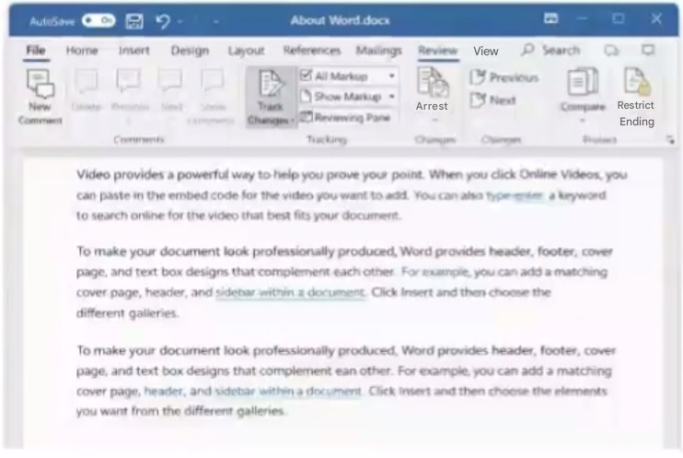
Question 29 of 29 Which practice should be used when sharing photos online?
A. Always include the names of everyone in the photo to give proper credit
B. Always tag everyone in the photo to make sure they see it
C. Add captions that provide context to the photos
D. Share photos on your public account of your friends and family
Question 30 of 30 You are using a new software program to create a presentation. You need to use a function that you are unfamiliar with. For each resource, select Yes if you could use it to find help or No if you could not.
Statement | Yes | No
"WRONG! Did you do ANY RESEARCH before posting this?" | ☐ | ◉
"Many doctors, including Jane Smith of Harvard Medical School, disagree." | ◉ | ☐
"It can be difficult to research everything, but there are many different sources to look at concerning this issue." | ◉ | ☐
"This is just wrong and makes you look foolish! Obviously you didn't look at the research from Harvard Medical School!" | ☐ | ◉

